Instructor ________________________________________

Florida Health Literacy Grant Initiative
Pre- Assessment
Staying Healthy for Beginners Answer Key
Name: ______________________________________________
Today's Date:_________________________________________

Circle the correct answer:
- A person who feels well and goes to the doctor is having a check-up.
True False

- Vitamins are a nutrient.
True False

- What number should you call if there is an emergency?

A. B.
211
911

- Over-the-counter (OTC) medicines can have side effects.
True False

- Obesity is
A. being healthy B. being very overweight

- When you go to the doctor you pay a set fee and your insurance pays the rest. This set fee is called
A. a premium B. a co-pay

- A health history form helps a doctor know about
A. your health insurance B. you and your family's health problems
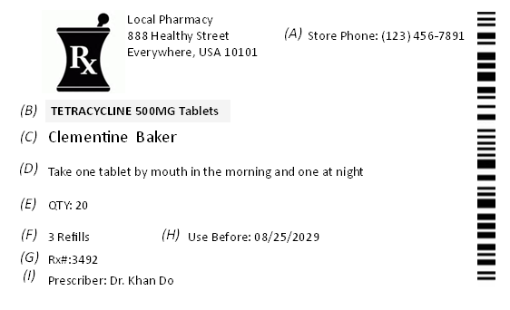
Select the correct letter choice from the medicine label for questions 5-8.

- Whose prescription this is? ___C___

- How often should this medicine be taken? ___D___

- How many tablets were prescribed? ___E___

- What is the name of this medicine? ___B___

- Which one shows a healthy diet?
A 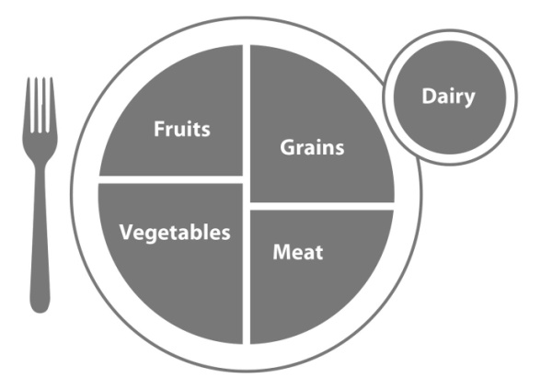 B. 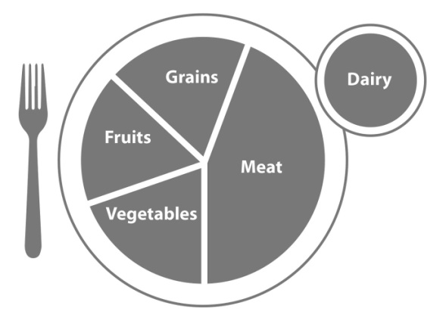

- Which has more sodium?
A. Chicken Noodle Soup B. Fresh Tomatoes

